**The Wright Place Child Development Center’s Closures**

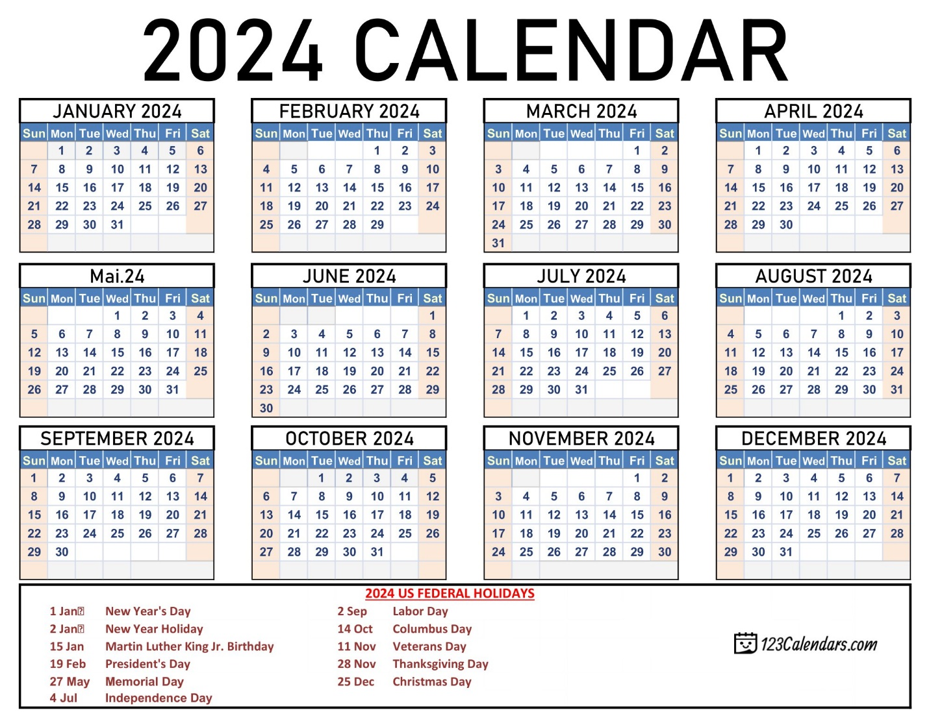

y

KEY:

Holiday

Notice: We have only used 3 of our 5 vacation days. Last 2 will be announced in advance.

Vacation

Notice: October’s Date hasn’t been selected yet!

In-Service/ Quarterly Staff Development Day

Early Release (2:00pm) (4:00pm)

**We follow Guilford County Schools for closures pertaining to Inclement Weather**

Please keep this calendar in a good spot!! Individual reminder notices may not be provided to families.

2804 Randleman Road Suite U/V

(336) 617-0897